Information Pack

Lead Lawyer

Lead Lawyer
Join our award-winning and thriving team of public lawyers.
We are looking for an experienced, ambitious solicitor or barrister to litigate public law cases and help manage our small, highly-motivated casework team. This is a new and senior post. It is an opportunity for a lawyer with existing judicial review or litigation experience - either in legal aid or the corporate sector - to develop their career to become a leading public law specialist.
PLP is a growing and lawyer-led charity, which was founded in 1991. Our lawyers work creatively and collaboratively, and are supported by our in-house team of researchers. We act directly for individuals, and are regularly instructed by law firms, lawyers’ groups, such as the Law Centres Network, and other public interest organisations. Our legal team were behind the recent string of successful judicial reviews against government and the Legal Aid Agency, including to the proposed legal aid residence test (R (Public Law Project) v Lord Chancellor), the recent Housing Possession Court Duty Scheme tender (R (Law Centres Network) v Lord Chancellor) and the domestic violence evidence rules (R (Rights of Women) v Lord Chancellor).
PLP funding comes from a range of sources, including legal aid and charitable grants. Our mixed funding model gives the organisation financial security and stability, and means our lawyers are able to work to achievable income targets, with correspondingly lower levels of bureaucracy.

What is PLP
Public Law Project (PLP) works to ensure people who are disadvantaged and marginalised can hold the state to account. For almost 30 years we have helped civil society, advisers and lawyers use the law to prevent abuses of power and improve access to justice in England and Wales. We employ specialist lawyers who represent individuals, campaign groups and charities, often in high profile, high stakes, public interest litigation. Our researchers work in partnership with the UK’s leading academic institutions, and we run a national programme of conferences and training.
PLP is growing. We are expanding our operations and developing our in-house expertise to meet some extraordinary challenges and opportunities; from austerity to Brexit, from benefit sanctions to an unprecedented programme of justice reform.
Can you help us achieve access to justice?

Vision, Mission & Values

Employment information
Job title: Lead Lawyer
Contract term: Permanent
Location: Central London (currently Kings Cross).
The successful candidate may be invited to work remotely (ie from home or another office) one day a week.
Hours: The job is available full time (35 hours per week) or part time, although our starting point is an expectation of (around) four days a week minimum commitment, subject to negotiation.
Salary: £45,000 per annum, pro rata.
Pension: 10% per annum after one year. Statutory minimum during first year.
Leave: A full time member of staff has 25 ordinary annual leave days each year in addition to bank holidays (usually 8).
Probation period: 6 months.
Payment method: Payment is made by electronic transfer on or shortly before the 15th of each calendar month covering payment for that same calendar month.
Flexible working:
PLP is a family friendly employer. We are open to flexible working arrangements including those that will enable the post-holder to accommodate their care responsibilities.
PLP employees may be requested to attend occasional evening meetings. However, PLP recognises that post holders may have other commitments and seeks to be as flexible as possible in this regard. In addition, reasonable notice will be given of such commitments outside normal working hours where possible, and time off in lieu may be taken by arrangement.

These details are provided for information only and do not form part of an employment contract or job offer.

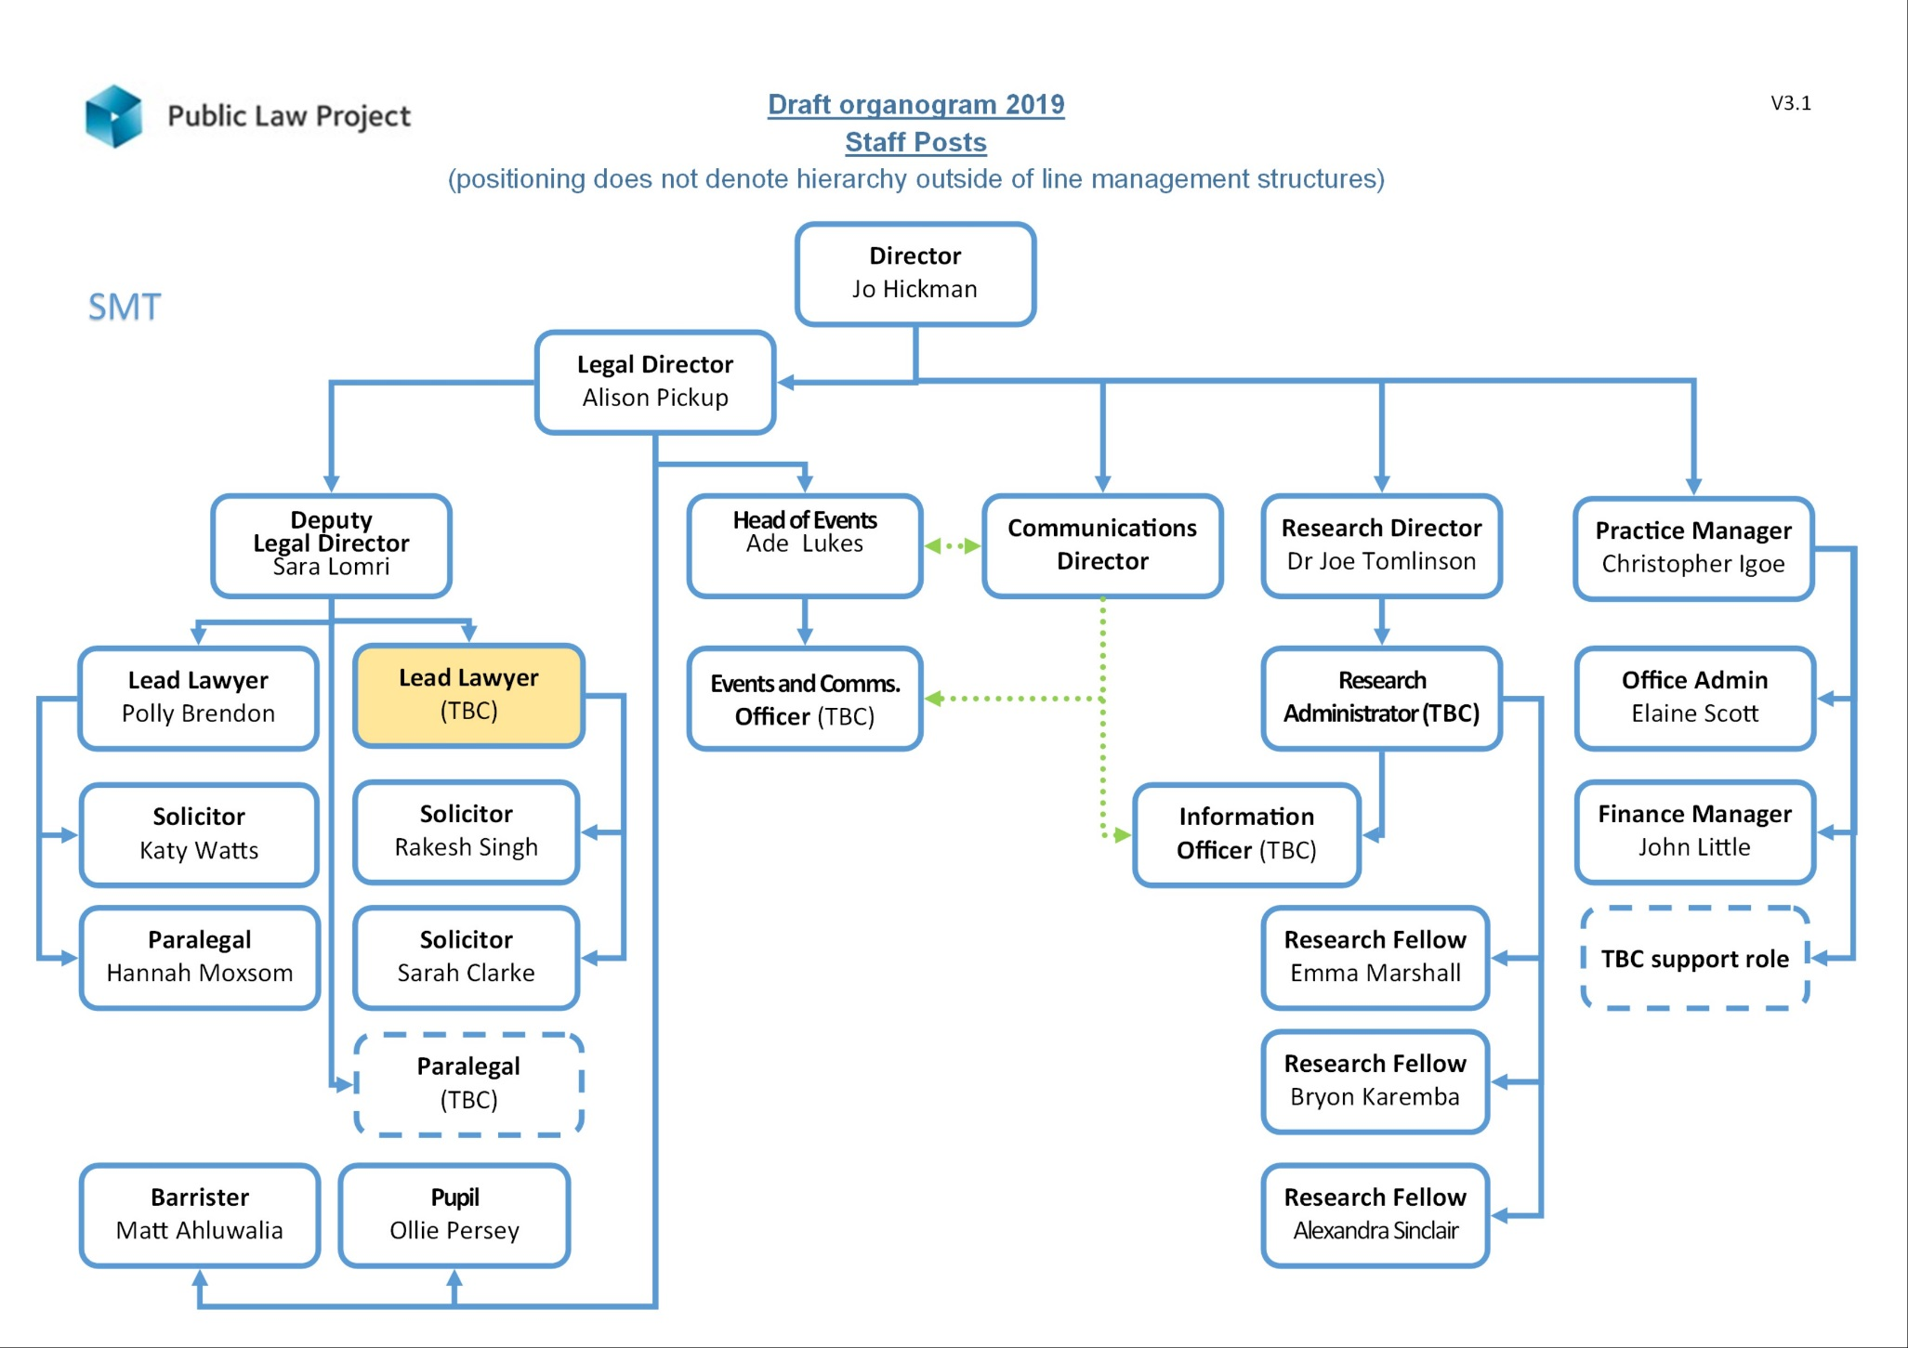

Job Description: Lead Lawyer
The Lead Lawyer will be based within PLP’s casework team, supervising other lawyers and caseworkers, and assisting with the delivery of the organisation’s strategy and goals. PLP delivers its strategy adopting a multidisciplinary approach combining casework, research, publications and training and events. Within our current 5-year strategic plan, we have adopted five ‘focus areas’ for our work: benefit sanctions; Brexit and the rule of law; the online court; legal aid; and access to judicial review. The Lead Lawyer will need to be confident in developing and delivering casework strategies in two or more of our Focus Areas, working with a multidisciplinary team from across our organisation, and liaising with the Lead Lawyer: Legal aid and members of the Senior Management team. The successful candidate will be a confident and creative lawyer, able to communicate at many levels and have experience and excellent skills of building and leading teams.
Primary Duties and Responsibilities
The following are primary duties of the Lead Lawyer:

Casework and litigation
- Conduct strategic, complex and sometimes high-profile judicial review litigation on behalf of individuals and organisations, using legal aid and other sources of funding

- Develop and maintain networks and referral sources to proactively generate work within Focus Areas and others for yourself and other members of the team

- Develop creative and innovative casework strategies within our Focus Areas in collaboration with Focus Area Leads and SMT.

- Identify and recruit external partners to further PLP’s work through collaboration and, consensus-building e.g. including with campaigners, researchers, civil society organisations, other practitioners and decision-makers.

- Work with the Senior Management Team to secure adequate resources for casework and Focus Area work including identifying potential funders, assisting in the preparation of funding applications for approval by SMT and complying with reporting and other requirements of funders as required by SMT

- Provide authoritative public law advice and information to civil society organisations and others, including delivering training, public speaking and contributing to publications.

- Maintain a caseload of a reasonable size and meet financial targets

- Ensure that all time recording and legal aid and other billing is undertaken in a timely and appropriate way.

- Compliance with all professional requirements. In particular, responsibilities to individual clients may sometimes require the postholder to work outside normal working hours.

Supervision
- Supervise members of the casework team, including skilled and experienced lawyers
- Ensure direct reports either meet their own financial targets and development objectives, or manage their performance for improvement.

Cross-departmental work
- In conjunction with the Events & Resource Development Manager, and other staff members where appropriate, to develop, maintain and disseminate information relating to PLP’s expert interest areas in law.

- In conjunction with the Events & Resource Development Manager, and other staff members where appropriate, to develop, maintain and deliver training courses and conferences to PLP’s client groups, and participate as a trainer in training events and conferences as required.

- To work closely with PLP’s Research team contributing ideas and feedback for their work, and contribute to the development of strategies across the Research and Casework teams.

General
- Assist with monitoring and evaluation, both internal for SMT/Board and external for funders and stakeholders, including the LAA.
- Undertake general administration and word-processing in connection with own work.
- Monitor own financial performance, ensuring adequate funding of cases (including limitations to public funding certificates), timely progression of billing etc.
- Contribute to PLP’s policy work. This may involve taking the lead in preparing draft written responses to particular issues on PLP’s behalf, for approval by the Director or Legal Director as appropriate.

- Represent PLP at meetings and other fora, as requested by the Legal Director or Deputy Legal Director.

- Undertake other tasks appropriate to the role as required.

Person Specification: Lead Lawyer
Knowledge, skills and competencies | Essential | Desirable
Understanding of, and commitment to, the aims of the Public Law Project
Awareness of current social and legal issues in the public law field
Qualified solicitor or barrister in England and Wales with significant public law expertise, or similar CILEX
Experience in conducting strategic and complex judicial review litigation to a very high standard
Excellent proven oral and written communication skills
Ability to develop creative legal strategies, including the use of litigation, and to innovate in the use of law.
Experience and skill in the supervision and line management of other caseworkers
Ability to build and maintain networks, proactively generate work and establish a strategically coherent caseload including experience of collaborating and consensus-building e.g. with clients, campaigners, researchers, other NGOs etc.
Working knowledge of funding litigation and casework.
The ability to meet reasonable billing targets and outputs on grant funded projects
The ability to communicate complex legal issues clearly, both orally and in writing, to various audiences
The ability to represent PLP in external including at meetings with Government representatives, Parliamentarians and other civil society organisations
Legal expertise within 2 or more of PLP’s focus areas
Experience in communicating with and training lawyers and advisers
Experience of influencing externally including dealing with the media
Experience of working in an organisation undergoing a period of significant change and development
A track record of leading or guiding teams in a common goal or initiative
Experience of engagement in policy or legislative developments with Government, Parliamentarians and other civil society organisations
Working knowledge of legal aid and ability to ensure compliance with contracting requirements
The ability to meet the LAA Supervisor Standard criteria in Public Law for the 2018 civil contract
Personal qualities, commitment and values | Essential | Desirable
Commitment to PLP’s core values of equality, integrity, expertise and teamwork
Ability to be self-servicing, including word processing skills, and to work flexibly and collegiately within a multi-disciplinary team
Able to communicate effectively with colleagues internally and also externally
Willingness and ability to travel to other parts of the country, occasionally staying overnight
Personal commitment and experience of team development
Willingness and ability to occasionally attend evening meetings
Right to work in the UK

Application process
PLP is an equal opportunities employer. We welcome applications from individuals regardless of age, disability, gender, marital status, pregnancy/maternity, race, religion and belief, sex or sexual orientation.
Candidates may ask for clarification of elements of the person specification and/or the application process, and may discuss any issues that might impact on how they would be able to undertake the work. PLP will not discuss issues that may give any candidate information that would give them an advantage in their application.
To apply please complete the application form which accompanies this information pack and send it to hr@publiclawproject.org.uk
The deadline for applications is 11.59pm, Sunday 20 January 2019.
A recruitment panel will be nominated for each vacancy. The recruitment panel will use the completed application form to assess each candidate's ability to meet the essential requirements of the job as set out in the person specification using a scoring system. The highest scoring applicants will be interviewed.
Interviews will be held the week commencing 28 January 2019.
Further information about the interview process will be provided to successful applicants. Interviews will usually consist of at least one practical test of your abilities relating to the role and a standard interview with a panel of at least two people. Please let us know in advance of your interview if you have a disability which may interfere with your ability to take part in a test and PLP will make reasonable adjustments to ensure the process is fair to all applicants.
Interview questions will be decided in advance based on their relevance to the job description and person specification and scored separately by interviewers. A score sheet will be set in advance, interviewers may only use information from the application form, the interview and any other assessment methods to inform their score.
Applicants who have a disability should note that our current building is located over four floors and regrettably has no lift facilities. If you have a disability which you think may interfere with your ability to do the job as described, please let us know and PLP will make reasonable adjustments both at interview and on appointment.
PLP keeps assessment records/notes for all applicants, whether shortlisted or not, for 12 months. They are stored securely and then destroyed securely after the above period.
All short-listed candidates shall be notified of their selection decision and can obtain feedback from the assessment if they request it. All such requests are dealt with by the Practice Manager who may pass them on to the relevant person if applicable.

Equality statement of intent
As an employer, PLP will treat all employees and job applicants equally and fairly and will not unlawfully discriminate against them. This also applies to volunteers, interns and anyone undertaking work experience with PLP. Our commitment to equal treatment extends to arrangements for recruitment and selection, terms and conditions of employment, access to training opportunities, access to promotion and transfers, grievance and disciplinary procedures, demotions, selection for redundancies, dress code, references, work allocation and any other employment related activities. Specifically, PLP will endeavour to ensure that:
I. Whenever practical, we will recruit and maintain a workforce which broadly reflects the diversity of the community in which we operate and serve. We will ensure that the style and content of our job adverts and recruitment materials convey this commitment, and always includes the statement that "The Public Law Project is an equal opportunity employer".
II. Subject to cost, we will ensure that job opportunities are advertised widely and to diverse audiences. Where appropriate, PLP will take positive action measures to attract applications from all sections of society and especially from those groups which are under-represented in our workforce.
III. We treat all job applicants equally and fairly and do not unlawfully discriminate against them. We do this by ensuring that we operate an open and fair recruitment process, and making decisions using selection criteria which do not discriminate.
IV. We will take every possible step to ensure that employees and volunteers are treated fairly, with the aim of creating a culture that respects and values each others’ differences, that is free of discrimination and promotes dignity, equality and diversity, and that encourages individuals to develop and maximise their true potential.
V. We recognise our continuing responsibility to develop the potential of all employees, removing any barriers, bias or discrimination that prevents progression or full contribution to the organisation’s performance. We will ensure that selection for promotion, training or other benefit is free from discrimination of any kind and is based on the employee’s experience and abilities and the needs of the job.
VI. We will make clear to all employees, volunteers and trustees that anyone who works for PLP in any capacity is entitled to be treated with dignity and respect, and that unlawful discrimination, intimidation, harassment and victimisation are disciplinary offences which will not be tolerated by the organisation and may lead to disciplinary action. We will provide clear and accessible procedures allowing allegations of such conduct to be promptly and sensitively investigated.
VII. We will provide flexibility to employees in relation to work requirements that may significantly impact on their personal needs and responsibilities and we will seek, as far as possible, to foster a culture that ensures an appropriate work – life balance. We also aim to be aware of days of cultural or religious significance that employees may wish to observe in an appropriate manner.

Privacy notice
When you apply for a job with PLP we will need to collect information about you including your employment history and contact details so that we can assess your suitability for the role and inform you about the progress of your application.
Your records will be kept securely whilst we consider your application. If your application is unsuccessful, we will keep your data until 6 months after the decision was made. If successful your recruitment information will be kept for 6 years after your last day working with us.
If you opt to provide equal opportunity data to PLP this will be anonymised and retained only as long as is necessary to record the recruitment decision against the anonymised data and no longer than six months.
We do not share recruitment information with third parties.

