Dear Sirs
Direct Communications Unit
2 Marsham Street
London
SW1P 4DF

T8286/17
KW
2 July 2019

We write further to our enclosed letter dated 27 July 2017, in which we requested that the Secretary of State for the Home Department exercise his power under s166 Policing and Crime Act 2017 to add the offence of soliciting or importuning under s32 Sexual Offences Act 1956 to the list of offences which can be disregarded under s92(1) Protection of Freedoms Act.

In your response to our letter, you stated that that the Secretary of State was in the process of considering whether to include extend the disregard scheme to include the offence of importuning. You were unable to provide us with a timetable for that consultation.

It has now been two years since our request. Our client is an elderly man with a conviction for an offence which has long been recognised as having been used in a discriminatory way against gay men, and which has been repealed on that basis. Until the Secretary of State takes steps to include this offence within the disregard scheme, our client remains unable to apply to have his conviction disregarded and cannot receive the pardon which is contingent on a successful application for a disregard.

If we do not receive a satisfactory response to this letter, setting out a timetable for the changes necessary to amend s92(1) Protection of Freedoms Act, we will be advising our client of his legal options.

Yours faithfully

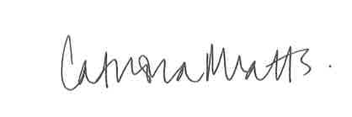

Katy Watts
Solicitor
Public Law Project
Tel: 0207 843 1269
Fax: 0207 837 7048
E-mail: k.watts@publiclawproject.org.uk

