Information Pack

Finance Officer

Advert
Public Law Project (PLP) is looking for a Finance Officer to help support our growing charity operate effectively. The successful candidate will be a team player, working closely both with other members of our Finance and Operations department and with our lawyers, researchers and events team to ensure they have the financial support needed to deliver our charitable activities. Whilst helping us to ensure people who are disadvantaged and marginalised can hold the state to account for unfair decisions you will develop your financial skills and experience working across a wide range of financial processes and duties.
This role includes a variety of responsibilities within day-to-day tasks such as identifying incoming receipts and investigating what they are to liaising with budget holders for approval of expenses and posting transactions to our accounting system. You will also work with our Finance Manager to support the production of payroll, VAT returns and have the opportunity to develop sector experience through the administration of restricted grants and casework finances. In time we will want to rely on you to take responsibility for a range of financial areas to be determined during your induction and initial training.
PLP support staff have the opportunity to be involved directly in the work of the charity through membership of one of our working groups. Working groups such as for Benefit Sanctions or Public Law and Technology – shape our work whether that is challenging unlawful withdrawal of welfare from people with mental health conditions or investigating how the use of algorithms in government decision making might unlawfully discriminate against minorities.

PLP wants to work with the best possible person for this role. To achieve that goal, we can be flexible. Whilst this post is conceived as a full-time post, part-time hours and other flexible working arrangements will also be considered.

What is PLP
Public Law Project (PLP) works to ensure that people who are disadvantaged and marginalised can hold the state to account. For almost 30 years we have helped civil society, advisers and lawyers use the law to prevent abuses of power and improve access to justice in England and Wales. We employ specialist lawyers who represent individuals, campaign groups and charities, often in high profile, high stakes, public interest litigation. Our researchers work in partnership with the UK’s leading academic institutions, and we run a national programme of conferences and training.
PLP is growing. We are expanding our operations and developing our in-house expertise to meet some extraordinary challenges and opportunities; from legal aid to benefit sanctions, from constitutional reform to the use of algorithms in Government decision-making.

Vision, Mission & Values

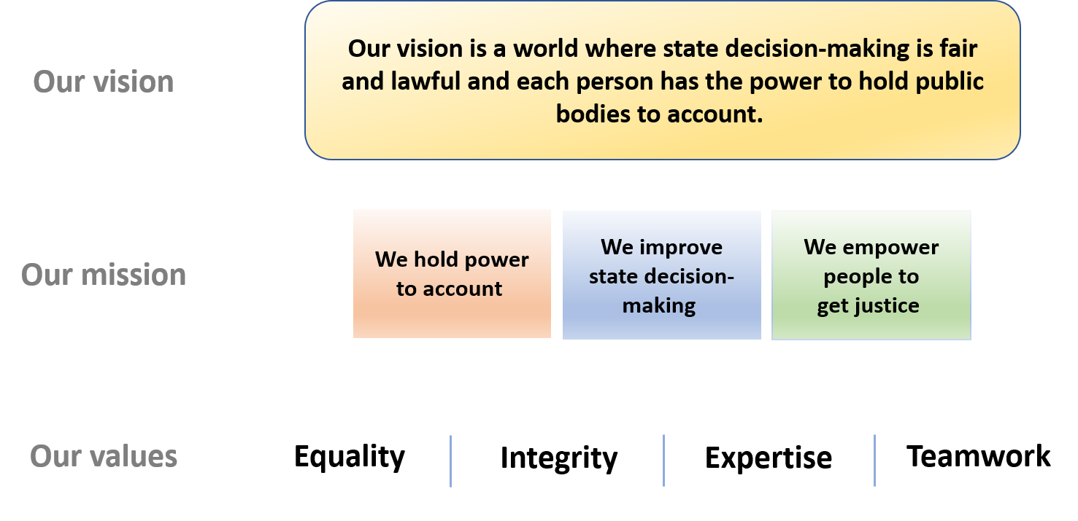

Employment information
Job title: Finance Officer
Contract term: Permanent
Location: Central London (EC1V). Currently working from home during lockdown with the option to work from the office on occasions.
Hours: 35 per week (although we would consider part time applications)
Salary: £24,476.38 (subject to annual cost of living review from 1 April 2021)
Pension: 10% per annum after one year. Statutory minimum during first year.
Leave: A full time member of staff has 25 ordinary annual leave days each year in addition to bank holidays (usually 8).
Probation period: 6 months. Benefits may be offered at a reduced level during the probation period.
Payment method: Payment is made by electronic transfer on or shortly before the 15th of each calendar month covering payment for that same calendar month.
Flexible working:
PLP is a family friendly employer. We are open to flexible working arrangements including those that will enable the post-holder to accommodate their care responsibilities.
PLP employees may be requested to attend occasional evening meetings. However, PLP recognises that post holders may have other commitments and seeks to be as flexible as possible in this regard. In addition, reasonable notice will be given of such commitments outside normal working hours where possible, and time off in lieu may be taken by arrangement.

These details are provided for information only and do not form part of an employment contract or job offer.
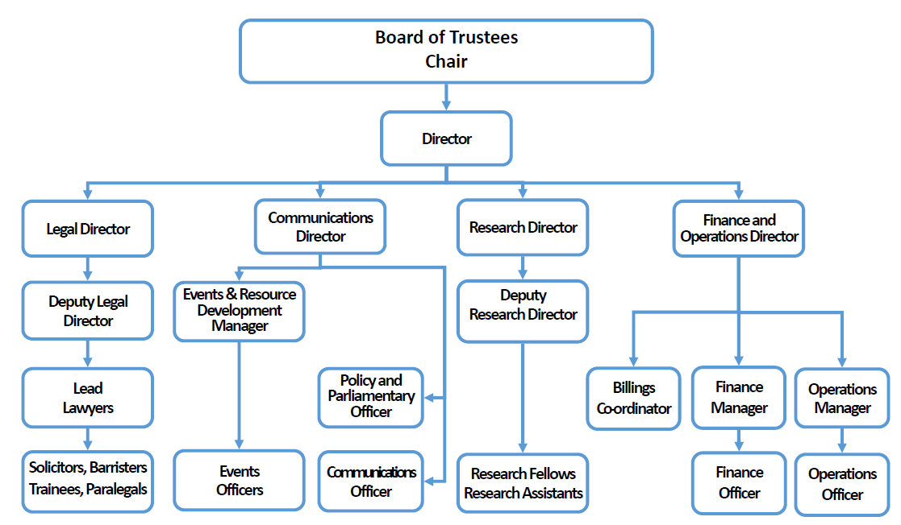

Job Description: Finance Officer
The Finance Officer supports the day-to-day effective operation of PLP finances.
The role is line managed by the Finance Manager and works closely with other members of the Finance and Operations team.

Primary Duties and Responsibilities
The following is an illustrative but not exclusive list of the primary duties and responsibilities of the role:

Finances
- Monitoring day-to-day financial operations of the charity including identifying incoming receipts and authorisation of expenditure.
- Maintaining good financial records including verifying, posting, allocating and filing financial transactions to a good standard
- Maintain and balance PLP’s ledgers, reconciling bank accounts and supporting the preparation of financial schedules in line with sound bookkeeping and accounting procedures;
- Production of aged debt reports and systematic reminding debtors of their outstanding fees
- Supporting PLP payroll processes
- Supporting the production of VAT returns
- Supporting the administration of the charity’s grant income from trusts and foundation
- Supporting casework finances including maintaining client ledgers and the client account; keeping accurate records of disbursements, payments on account and assisting the billing of PLP’s casework fees
- Setting up payments.
- Assisting with the financial management of event bookings.
- Management of petty cash receipts and reconciliation.
- Assisting with routine financial administration.

General
- Support a diverse and inclusive workplace.
- Support the Finance Manager and Finance and Operations Directions discharge their duties
- Work with the Operations Officer and other departmental staff to request and provide occasional support during busy periods and where staff are unavailable to perform their essential primary duties.
- Work with the Billings Coordinator on casework finances and other support staff to request and provide occasional cross-departmental support during busy periods and where staff are unavailable to perform their essential primary duties.
- Undertake other tasks appropriate to the role as requested by the Finance Manager and/or the senior leadership team
Person Specification: Finance Officer
Knowledge, Skills and Competencies | Essential | Desirable
Several years experience in a finance role | ✓
Relevant finance qualification |  | ✓
Proficient with the use of Microsoft Office software. | ✓
Intermediate Excel skills (confident user of vlookups, sumifs, basic pivots for example) | ✓
Good mathematical skills and able to do financial calculations efficiently and accurately. | ✓
Excellent attention to detail and thoroughness | ✓
Good time management skills. | ✓
Good written communication skills. | ✓

Personal qualities, commitment and values | Essential | Desirable
Team player. | ✓
Discretion to organise and handle confidential information appropriately. | ✓
Attitude conducive to working in a small, charitable organisation including the willingness to take on a wide range of tasks. | ✓
Commitment to equal opportunities. | ✓
Commitment to PLP’s core values of equality, integrity, expertise and teamwork. | ✓
Willingness and ability to occasionally attend evening meetings where required. |  | ✓
Willingness and ability to travel to other parts of the country, occasionally staying overnight and attending evening meetings
where required.
Right to work in the UK

Application process
PLP is an equal opportunities and Disability Confident Employer. We value diversity, we have a diverse team particularly among women and the LGBT+ community, and, we acknowledge that we currently have an underrepresentation from Black, Asian and Minority Ethnic people compared to our beneficiaries and within the London-charity sector. We are continuously taking actions to improve the diversity of our team. We welcome all applicants and are actively encouraging applicants particularly from Black, Asian and minority ethnic people and disabled people.
Candidates may ask for clarification of elements of the person specification and/or the application process, and may discuss any issues that might impact on how they would be able to undertake the work. PLP will not discuss issues that may give any candidate information that would give them an advantage in their application.
To apply please complete the application form which accompanies this information pack and send it to hr@publiclawproject.org.uk.
The deadline for applications is 11.59pm Sunday 16th May 2021.
A recruitment panel will be nominated for each vacancy. The recruitment panel will use the completed application form to assess each candidate's ability to meet the essential requirements of the job as set out in the person specification using a scoring system. The highest scoring applicants will be interviewed.
Interviews will be held on Wednesday and Thursday 26 and 27 May 2021.
Further information about the interview process will be provided to successful applicants. Interviews will usually consist of at least one practical test of your abilities relating to the role and a standard interview with a panel of at least two people. Please let us know in advance of your interview if you have a disability which may interfere with your ability to take part in a test and PLP will make reasonable adjustments to ensure the process is fair to all applicants.
Interview questions will be decided in advance based on their relevance to the job description and person specification and scored separately by interviewers. A score sheet will be set in advance, interviewers may only use information from the application form, the interview and any other assessment methods to inform their score.
If you have a disability which you think may interfere with your ability to do the job as described, please let us know and PLP will make reasonable adjustments both at interview and on appointment.
PLP keeps assessment records/notes for all applicants, whether shortlisted or not, for 12 months. They are stored securely and then destroyed securely after the above period.
All short-listed candidates shall be notified of their selection decision and can obtain feedback from the assessment if they request it. All such requests are dealt with by the Practice Manager who may pass them on to the relevant person if applicable.

Equality statement of intent
As an employer, PLP will treat all employees and job applicants equally and fairly and will not unlawfully discriminate against them. This also applies to volunteers, interns and anyone undertaking work experience with PLP. Our commitment to equal treatment extends to arrangements for recruitment and selection, terms and conditions of employment, access to training opportunities, access to promotion and transfers, grievance and disciplinary procedures, demotions, selection for redundancies, dress code, references, work allocation and any other employment related activities. Specifically, PLP will endeavour to ensure that:
I. Whenever practical, we will recruit and maintain a workforce which broadly reflects the diversity of the community in which we operate and serve. We will ensure that the style and content of our job adverts and recruitment materials convey this commitment, and always includes the statement that "The Public Law Project is an equal opportunity employer".
II. Subject to cost, we will ensure that job opportunities are advertised widely and to diverse audiences. Where appropriate, PLP will take positive action measures to attract applications from all sections of society and especially from those groups which are under-represented in our workforce.
III. We treat all job applicants equally and fairly and do not unlawfully discriminate against them. We do this by ensuring that we operate an open and fair recruitment process, and making decisions using selection criteria which do not discriminate.
IV. We will take every possible step to ensure that employees and volunteers are treated fairly, with the aim of creating a culture that respects and values each others’ differences, that is free of discrimination and promotes dignity, equality and diversity, and that encourages individuals to develop and maximise their true potential.
V. We recognise our continuing responsibility to develop the potential of all employees, removing any barriers, bias or discrimination that prevents progression or full contribution to the organisation’s performance. We will ensure that selection for promotion, training or other benefit is free from discrimination of any kind and is based on the employee’s experience and abilities and the needs of the job.
VI. We will make clear to all employees, volunteers and trustees that anyone who works for PLP in any capacity is entitled to be treated with dignity and respect, and that unlawful discrimination, intimidation, harassment and victimisation are disciplinary offences which will not be tolerated by the organisation and may lead to disciplinary action. We will provide clear and accessible procedures allowing allegations of such conduct to be promptly and sensitively investigated.
VII. We will provide flexibility to employees in relation to work requirements that may significantly impact on their personal needs and responsibilities and we will seek, as far as possible, to foster a culture that ensures an appropriate work – life balance. We also aim to be aware of days of cultural or religious significance that employees may wish to observe in an appropriate manner.

Privacy notice
When you apply for a job with PLP we will need to collect information about you including your employment history and contact details so that we can assess your suitability for the role and inform you about the progress of your application.
Your records will be kept securely whilst we consider your application. If your application is unsuccessful, we will keep your data until 6 months after the decision was made. If successful your recruitment information will be kept for 6 years after your last day working with us.
If you opt to provide equal opportunity data to PLP this will be anonymised and retained only as long as is necessary to record the recruitment decision against the anonymised data and no longer than six months.
We do not share recruitment information with third parties.

