Information Pack
Operations Manager

Advert
Public Law Project (PLP) is looking for an Operations Manager to manage and support the effective operation of our growing charity.
The successful candidate will be a team player, working closely both with other members of the finance and operations department and with our lawyers, researchers and events team to ensure they have the support needed to deliver our charitable activities. Your blend of skills and experience across HR, compliance, premises and IT and information management will be crucial to helping us to ensure people who are disadvantaged and marginalised can hold the state to account for unfair decisions.
This role includes a wide range of responsibilities and the successful candidate will enjoy the variety in the role and have the core skills necessary to provide excellent management of all areas of the post including areas where you will not be expert. This includes strong problem solving skills, commitment to taking responsibility and excellent time and task management. You will be dedicated to self-development and learning and be able to identify when you yourself need professional advice or additional support. Within this context expertise or particular interests in one area, for example in HR, would also be beneficial to the role.
Prioritising development of PLP as a resilient, connected organisation is one of the three central organisational goals PLP has adopted in our strategy for 2021-22. Your role will be critical to our ability to mitigate the effects of the external crisis on the effectiveness of our team, playing a key role in developing and leading a programme of well-being training and resources and fostering a culture of psychological safety and inclusivity. As we learn how to work optimally in a hybrid working environment you will be crucial in ensuring our office and technology is geared to support collaborative working and will contribute to developing our thinking on supporting internal communication and connectivity. PLP is a diverse team and benefits from an inclusive culture – your role will help us build on this strength.
PLP support staff have the opportunity to be involved directly in the work of the charity through membership of one of our working groups. Working groups such as for Benefit Sanctions or Public Law and Technology – shape our work whether that is challenging unlawful withdrawal of welfare from people with mental health conditions or investigating how the use of algorithms in government decision making might unlawfully discriminate against minorities.

PLP wants to work with the best possible person for this role. To achieve that goal, we can be flexible. Whilst this post is conceived as a full-time post, part-time hours, job-share and other flexible working arrangements will also be considered.

What is PLP
Public Law Project (PLP) works to ensure that people who are disadvantaged and marginalised can hold the state to account. For almost 30 years we have helped civil society, advisers and lawyers use the law to prevent abuses of power and improve access to justice in England and Wales. We employ specialist lawyers who represent individuals, campaign groups and charities, often in high profile, high stakes, public interest litigation. Our researchers work in partnership with the UK’s leading academic institutions, and we run a national programme of conferences and training.
PLP is growing. We are expanding our operations and developing our in-house expertise to meet some extraordinary challenges and opportunities; from legal aid to benefit sanctions, from constitutional reform to the use of algorithms in Government decision-making.

Vision, Mission & Values
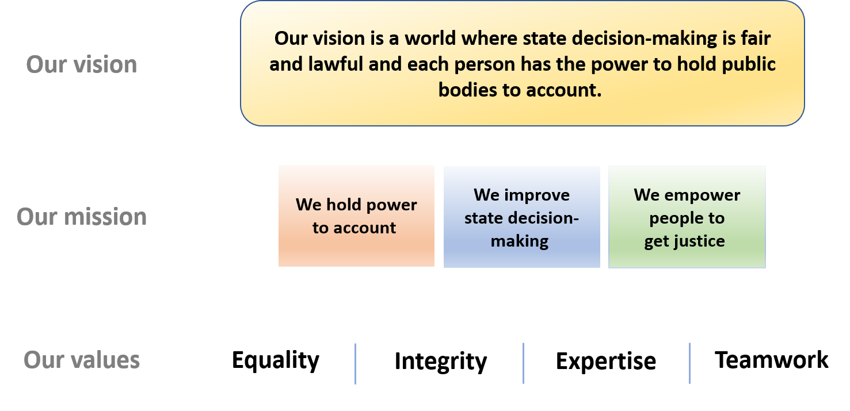

Employment information
Job title: Operations Manager
Contract term: Permanent
Location: Central London (EC1V). Currently working from home during lockdown with the option to work from the office on occasions.
Hours: 35 per week (although we would consider job-share and/or part time applications)
Salary: £39,022.16 (subject to annual cost of living review from 1 April 2021)
Pension: 10% per annum after one year. Statutory minimum during first year.
Leave: A full time member of staff has 25 ordinary annual leave days each year in addition to bank holidays (usually 8).
Probation period: 6 months. Benefits may be offered at a reduced level during the probation period.
Payment method: Payment is made by electronic transfer on or shortly before the 15th of each calendar month covering payment for that same calendar month.
Flexible working:
PLP is a family friendly employer. We are open to flexible working arrangements including those that will enable the post-holder to accommodate their care responsibilities.
PLP employees may be requested to attend occasional evening meetings. However, PLP recognises that post holders may have other commitments and seeks to be as flexible as possible in this regard. In addition, reasonable notice will be given of such commitments outside normal working hours where possible, and time off in lieu may be taken by arrangement.

These details are provided for information only and do not form part of an employment contract or job offer.
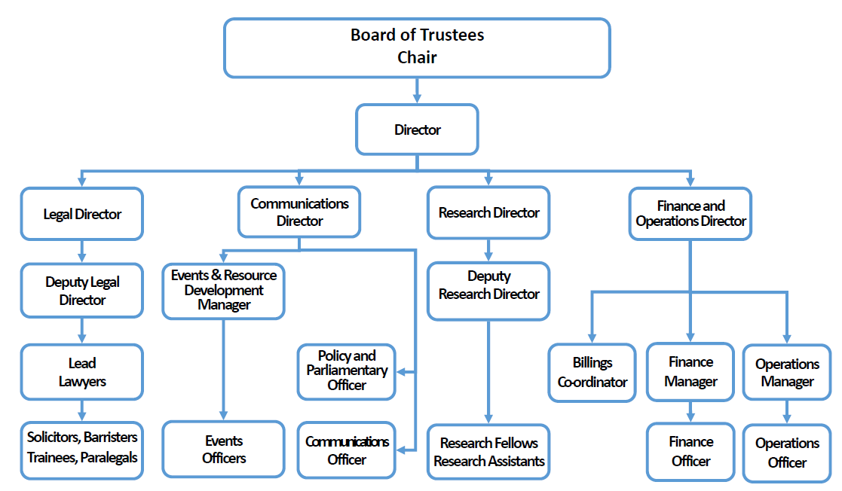

Job Description: Operations Manager
The Operations Manager is responsible for managing the day-to-day effective operation of PLP support functions including HR, regulatory, IT, premises, data and information management.
The Operations Manager reports to and is managed by the Finance and Operations Director or another senior manager in their absence.
The post-holder works closely with the rest of the Finance and Operations team, the Senior Leadership Team and other managers and the trustee personnel sub-committee.

Primary Duties and Responsibilities
The following are the primary duties and responsibilities of the Operations Manager:

Management and supervision
- Line management of the Operations Officer to assist you in your management of the support functions of the charity.
- Supervising the work of other staff and volunteers with support duties as appropriate to the role.

Human Resources Planning and Management
- To oversee and be responsible for recruitment including adverts, job descriptions and selection processes ensuring a diverse workforce.
- Produce and issue employment contracts and offer letters for new starters.
- Manage and develop PLP induction processes and ongoing staff training, learning and professional development.
- Provide leadership for PLP staff wellbeing and fostering a culture of inclusion.
- Oversee and manage a performance appraisal system.
- Maintain & monitor records of staff hours and absence due to sickness, holidays, etc.
- Liaise with the Finance Manager to administer payroll.
- Review HR policies and process and implement changes to regulatory requirements and keep pace with best employment practices to ensure all policies and procedures are compliant and support progressive working practices.
- Provide advice and support to managers on employee relations issues including disciplinary, grievance, performance, capability and other people issues.

Compliance
- Aiding the Finance and Operations Director and PLP’s company secretary in the discharge of their duties and ensuring compliance with charity law and regulations.
- Working with appropriate members of the casework team to ensure compliance with the requirements of the Legal Aid Agency, the SRA Code of Conduct and the Law Society’s LEXCEL quality standard.
- Ensure compliance with all other relevant legislation and regulations.

Premises & Information Technology
- Manage PLP office space to ensure it provides a conducive work environment supporting the effective operation of the charity.
- Manage PLP information technology resources to ensure our systems support conducive working and collaboration.
- Manage and develop systems that support collaboration between office and remote workers.
- Support staff trouble-shooting common IT problems that arise escalating to PLP’s external IT support as appropriate.
- Ensure a positive, healthy and safe work environment in accordance with all appropriate legislations and regulations.

Information Management
- Support the Finance and Operations Director in their role as Data Protection lead, ensuring the development and implementation of policies and procedures necessary to maintain compliance.
- Inform and advise the organisation, its employees and volunteers about the obligations to comply with the GDPR and other data protection laws.
- Champion knowledge management and the development of systems and processes to enable more effective collaboration, collection and dissemination of information across the organisation (architecture/internal systems and policies), particularly ensuring the office and departmental manuals and procedures are developed and updated.
- Ensure that information records are kept securely, backed up and protected from common online threats and breaches of confidentiality.
- Working with the Operations Officer and other staff ensure information is accurate and destroyed as appropriate.

General
- Support a diverse and inclusive workplace.
- Support the fair and equitable delivery of PLP's charitable activities.
- Support the Finance and Operations Director Ensure PLP's policies and procedures are fair and equitable.
- Support and contribute to the development of departmental strategy and planning.
- Co-ordinate and where needed provide a first point of contact for email, phone calls and office visitors and that minimum office staffing levels are maintained.
- Support the Finance and Operations Director discharging their goals to help monitor and evaluate the impact of PLP’s work and the efficacy of its resource allocation.
- Assisting with the departmental responsibility to provide a secretariat function to the Board of Trustees and Senior Leadership Team including taking of minutes, arranging meetings and providing executive support to the Director where appropriate to the role.
- Undertake other tasks appropriate to the role as requested by the Finance and Operations Director or the Board.

Person Specification: Operations Manager
Knowledge, Skills and Competencies | Essential | Desirable
Experience in a role with substantial human resources responsibilities or a relevant qualification. | ✓
Knowledge and experience necessary for the effective management of robust IT and phone systems and office infrastructure. | ✓
Knowledge of and demonstrable experience of ensuring compliance of relevant legislation including employment law, health & safety legislation, charity law, HMRC, companies law, GDPR. | ✓
Intermediate level skills with Microsoft Office and the ability to provide solutions to common technical issues. | ✓
Excellent time and task management skills. | ✓
Good written communication skills. | ✓
Ability to conceive, plan, deliver and evaluate the success of internal projects | ✓
CIPD qualification minimum level 5 or equivalent qualification |  | ✓
Experience of managing staff |  | ✓
Excellent IT skills and/or experience in an IT role and/or a relevant qualification. |  | ✓
Experience in data or information administration and/or a relevant qualification. |  | ✓
Experience of risk management |  | ✓
Experience of business planning, monitoring and evaluation |  | ✓

Personal qualities | Essential | Desirable
Team player. | ✓
Discretion to organise and handle confidential information appropriately. | ✓
Attitude conducive to working in a small, charitable organisation including the willingness to take on a wide range of tasks. | ✓
Competence to build and effectively manage interpersonal relationships at all levels of seniority. | ✓
Excellent interpersonal skills, showing awareness of own emotions and the effect you have on others | ✓
Strong problem solving skills, commitment to taking responsibility for problems and finding solutions. | ✓
Dedication to self-development and learning with a commitment to applying best and developing practice to your areas of responsibility | ✓
Passionate commitment to equality, diversity and inclusion. | ✓
Commitment to PLP’s core values of equality, integrity, expertise and teamwork. | ✓
Experience of discrimination and disadvantage |  | ✓
Right to work in the UK

Application process
PLP is an equal opportunities and Disability Confident Employer. We value diversity, we have a diverse team particularly among women and the LGBT+ community, and, we acknowledge that we currently have an underrepresentation from Black, Asian and Minority Ethnic people compared to our beneficiaries and within the London-charity sector. We are continuously taking actions to improve the diversity of our team. We welcome all applicants and are actively encouraging applicants particularly from Black, Asian and minority ethnic people and disabled people.
Candidates may ask for clarification of elements of the person specification and/or the application process, and may discuss any issues that might impact on how they would be able to undertake the work. PLP will not discuss issues that may give any candidate information that would give them an advantage in their application.
To apply please complete the application form which accompanies this information pack and send it to hr@publiclawproject.org.uk.
The deadline for applications is 11.59pm Wednesday 19 May 2021.
A recruitment panel will be nominated for each vacancy. The recruitment panel will use the completed application form to assess each candidate's ability to meet the essential requirements of the job as set out in the person specification using a scoring system. The highest scoring applicants will be interviewed.
Interviews will be held on Monday and Tuesday 7 and 8 June 2021.
Further information about the interview process will be provided to successful applicants. Interviews will usually consist of at least one practical test of your abilities relating to the role and a standard interview with a panel of at least two people. Please let us know in advance of your interview if you have a disability and require reasonable adjustments for the interview or assessment process to ensure the process is fair and equitable to all applicants.
Interview questions will be decided in advance based on their relevance to the job description and person specification and scored separately by interviewers. A score sheet will be set in advance, interviewers may only use information from the application form, the interview and any other assessment methods to inform their score.
PLP keeps assessment records/notes for all applicants, whether shortlisted or not, for 12 months. They are stored securely and then destroyed securely after the above period.
All short-listed candidates shall be notified of their selection decision and can obtain feedback from the assessment if they request it. All such requests are dealt with by the Practice Manager who may pass them on to the relevant person if applicable.
Equality statement of intent
As an employer, PLP will treat all employees and job applicants equally and fairly and will not unlawfully discriminate against them. This also applies to volunteers, interns and anyone undertaking work experience with PLP. Our commitment to equal treatment extends to arrangements for recruitment and selection, terms and conditions of employment, access to training opportunities, access to promotion and transfers, grievance and disciplinary procedures, demotions, selection for redundancies, dress code, references, work allocation and any other employment related activities. Specifically, PLP will endeavour to ensure that:
I. Whenever practical, we will recruit and maintain a workforce which broadly reflects the diversity of the community in which we operate and serve. We will ensure that the style and content of our job adverts and recruitment materials convey this commitment, and always includes the statement that "The Public Law Project is an equal opportunity employer".
II. Subject to cost, we will ensure that job opportunities are advertised widely and to diverse audiences. Where appropriate, PLP will take positive action measures to attract applications from all sections of society and especially from those groups which are under-represented in our workforce.
III. We treat all job applicants equally and fairly and do not unlawfully discriminate against them. We do this by ensuring that we operate an open and fair recruitment process, and making decisions using selection criteria which do not discriminate.
IV. We will take every possible step to ensure that employees and volunteers are treated fairly, with the aim of creating a culture that respects and values each others’ differences, that is free of discrimination and promotes dignity, equality and diversity, and that encourages individuals to develop and maximise their true potential.
V. We recognise our continuing responsibility to develop the potential of all employees, removing any barriers, bias or discrimination that prevents progression or full contribution to the organisation’s performance. We will ensure that selection for promotion, training or other benefit is free from discrimination of any kind and is based on the employee’s experience and abilities and the needs of the job.
VI. We will make clear to all employees, volunteers and trustees that anyone who works for PLP in any capacity is entitled to be treated with dignity and respect, and that unlawful discrimination, intimidation, harassment and victimisation are disciplinary offences which will not be tolerated by the organisation and may lead to disciplinary action. We will provide clear and accessible procedures allowing allegations of such conduct to be promptly and sensitively investigated.
VII. We will provide flexibility to employees in relation to work requirements that may significantly impact on their personal needs and responsibilities and we will seek, as far as possible, to foster a culture that ensures an appropriate work – life balance. We also aim to be aware of days of cultural or religious significance that employees may wish to observe in an appropriate manner.

Privacy notice
When you apply for a job with PLP we will need to collect information about you including your employment history and contact details so that we can assess your suitability for the role and inform you about the progress of your application.
Your records will be kept securely whilst we consider your application. If your application is unsuccessful, we will keep your data until 6 months after the decision was made. If successful your recruitment information will be kept for 6 years after your last day working with us.
If you opt to provide equal opportunity data to PLP this will be anonymised and retained only as long as is necessary to record the recruitment decision against the anonymised data and no longer than six months.
We do not share recruitment information with third parties.

