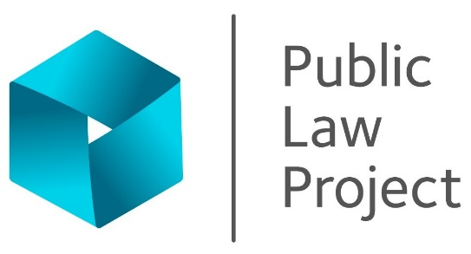

Information pack
Community Network Manager

June 2026

Join our team
This is a pivotal moment to join Public Law Project. As part of our five-year strategy, we are deepening our commitment to centring the voices and experiences of marginalised communities — and this new role is at the heart of that work.
As Community Network Manager, you will establish and lead our new Community Knowledge Exchange, bringing together people with lived experience of marginalisation, frontline partners, lawyers, researchers and others to share knowledge, build collective power and shape fairer systems. You will build and sustain the relationships and infrastructure that ensure community insight drives our litigation strategy, policy influence and advocacy — working in ways that are ethical, equitable and genuinely co-productive.
This is a rare opportunity to shape something from the start. You will develop the networks, tools and approaches that help PLP engage meaningfully with communities, while also acting as an internal champion — building our organisational capacity to work in partnership with lived experience in non-extractive ways.
If you are an experienced community organiser or network coordinator who is passionate about putting lived experience at the centre of social change, we would love to hear from you.
As part of our commitment to recruit fairly we use anonymised-selection processes until interview, offer additional interview opportunities to the highest-scoring candidates from under-represented communities, and use ‘tie-breaker’ provisions at all stages of our selection process.
This work is made possible by The National Lottery Community Fund's Solidarity Fund. Thanks to National Lottery players, Public Law Project has received more than £3.5 million over five years from The National Lottery Community Fund. The funding will be used for strategic legal action, co-produced research and communications to challenge unfair decisions and shape fairer systems.
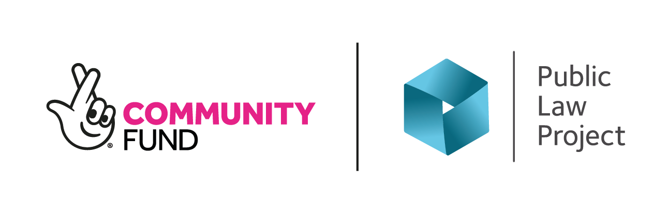

Who we are
At Public Law Project (PLP), we work to champion fundamental rights and hold power to account. Our legal challenges have played a pivotal role in successful cases. In recent years this has included:
- The fight against the Rwanda deportation policy
- The Government’s attempts to renege on Windrush commitments
- Attempts to radically cut disability benefits to 100,000 people without lawful consultation
- Preventing the implementation of draconian and unconstitutional anti protest laws
- Being a leading voice on public sector use of AI
Our work is highly respected, impactful, and deeply valued across the legal and social justice sectors. To continue tackling the most pressing legal injustices of our time, we need you to engage and inspire those who believe in our mission and have the means to support it.

Vision, mission and values
Our 2025-2030 strategy sets out our purpose which is to advance fairness in society through public law and our vision of a fair and inclusive society secured by a just and confident state. Our values are: equity, expertise, collaboration and courage. You can find out more about our strategy here.
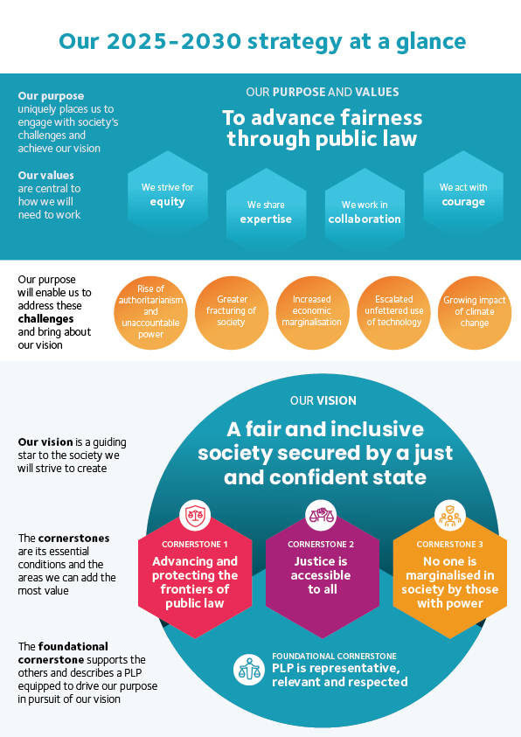

Employment information
Job title: Community Network Manager
Reports to: Communications & Engagement Director
Contract term: Permanent
Location: Central London (EC1V). Homeworking within flexible working policies. New starters are required to work in the office 2 days a week for the first 3 months
Hours: Full-time or Part-time - minimum 4 days / 28h per week
Salary: £40,000 pa, eligible for cost-of-living uplift this year
Pension: 10% per annum after one year. Statutory minimum during first year.
Leave: A full-time member of staff has 25 ordinary annual leave days each year in addition to bank holidays (usually 8).
Probation period: 6 months. Benefits may be offered at a reduced level during the probation period.
Payment method: Payment is made by electronic transfer on or shortly before the 15th of each calendar month covering payment for that same calendar month.
Flexible working:
PLP is a family friendly employer. We are open to flexible working arrangements from day one, including those that will enable the post-holder to accommodate their care responsibilities.
PLP employees may be requested to attend occasional evening meetings. However, PLP recognises that post holders may have other commitments and seeks to be as flexible as possible in this regard. In addition, reasonable notice will be given of such commitments outside normal working hours where possible, and time off in lieu may be taken by arrangement.

These details are provided for information only and do not form part of an employment contract or job offer.
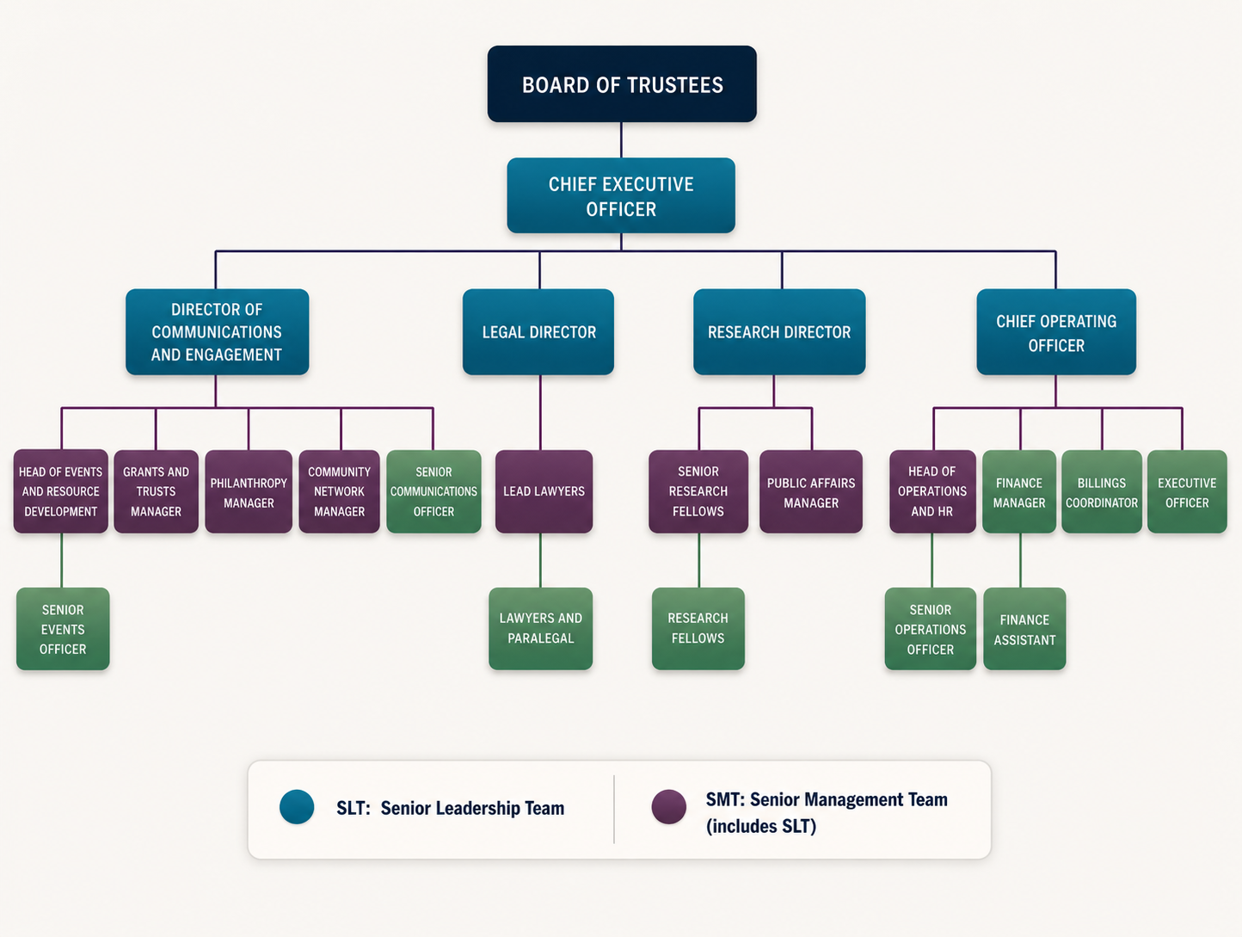
2021/22 V2
Job purpose
The Community Network Manager will establish and lead PLP's Community Knowledge Exchange — a new network bringing together people and organisations with lived experience of marginalisation, frontline partners, lawyers, researchers and others to share knowledge and shape fairer systems.
At the heart of the role is a commitment to centring lived experience in PLP's work in ways that are ethical, equitable and non-extractive. The post holder will translate community insight into policy influence, strategic litigation and advocacy, while also strengthening PLP's internal capacity to engage in co-production and lived experience partnership working effectively.
They will develop and help to steward PLP's relationship with The National Lottery Community Fund and engage with the wider cohort of funded organisations, identifying opportunities for collaboration and collective endeavour. Internally, they will act as a champion and adviser, developing tools, guidance and approaches that help colleagues across PLP engage meaningfully with communities and frontline partners.
Key relationships
Reports to the Communications & Engagement Director, works closely with the wider Communications & Engagement team and is a member of the SMT. Collaborates across PLP with colleagues including from events, public affairs, research and casework teams and advise the Senior Leadership Team. Externally, represents PLP within the Community Knowledge Exchange network and The National Lottery Community Fund cohort, and facilitates and maintains relationships with community partners, frontline organisations and other stakeholders relevant to PLP's strategic priorities.
Primary duties and responsibilities
The following is an illustrative but not exclusive list of the primary duties and responsibilities of the role
Network development and coordination
- Establish, coordinate and grow the Community Knowledge Exchange – a network of people and organisations with lived and living experience of marginalisation, working with colleagues and frontline partners such as advice organisations and campaign groups.
- Manage relationships, communications and logistics for network members and meetings.
- Develop peer resource hubs and strong feedback loops between community insight and organisational delivery.
- Engage with the cohort of National Lottery funded organisations, making the most of connections and insights to shape the Community Knowledge Exchange and activities such as events.

- Connect PLP with communities and partners relevant to our strategic priorities. Uphold and promote PLP’s safeguarding policy, recognising and responding appropriately to concerns and escalating them through agreed procedures.
Knowledge exchange, influencing and storytelling
- Shape and develop network resources, working in collaboration with colleagues across the Communications & Engagement, Research and Casework teams and SLT.
- Work with the events team (which is part of the Communications & Engagement team) to develop and deliver convenings, meetings and trainings for the Community Knowledge Exchange and feed into PLP’s overall programme of events.
- Work with research and public affairs colleagues to support the co-production of research, policy and influencing work.
- Work with strategic communications colleagues to support and enable people with lived experience to share their stories publicly in ways that are ethical, empowering and on their own terms.
- Coordinate internal staff contributions to network delivery.
Funder relationship and programme development
- Play a lead role in developing PLP's relationship with The National Lottery Community Fund, acting as the primary point of contact for the development of the programme and support regular, high-quality communication and reporting.
- Represent PLP within the wider cohort of funded organisations, building relationships and identifying opportunities for collaboration, joint working and shared learning.
- Ensure that senior colleagues and the wider staff team are informed of developments in the programme, including emerging opportunities, funder priorities and cohort-wide initiatives.
- Shape the development of KPIs, in collaboration with others, and lead on tracking and reporting for PLP and sharing learnings internally and externally
- Contribute to and coordinate PLP's input into any collective communications, advocacy or other joint work across the cohort.
- Ensure PLP is well-positioned to respond to opportunities the funder makes available, including around communications support or additional resourcing.
Building capacity for lived experience partnership
- Advise colleagues on approaches to co-production and lived experience partnership working that are ethical, equitable and non-extractive.
- Shape and develop internal tools, guidance and resources to build organisational capacity in this area.
- Support teams across PLP to engage meaningfully with communities and frontline partners in their work.
- Act as an internal champion for centring lived experience across PLP's work, including casework, research, public affairs, strategic comms and events.
Management responsibilities and organisational contribution
- Contribute proactively as part of SMT to PLP’s strategy and goals.
- Role-model and embed PLP’s values and culture framework in day-to-day leadership and team development.
- Assist with management of the Communications & Engagement team e.g providing input on planning, chairing team meetings as appropriate, and assisting with recruitment, induction and training as required.
- Draw on network insight to contribute to organisational planning and strategy, including advising on emerging trends, risks and opportunities relevant to PLP’s priorities.
General duties
- Contribute to PLP’s general development, including improvement of systems, processes and ways of working.
- Ensure work is carried out in accordance with PLP policies, procedures, and relevant legal and regulatory requirements.
- Participate in PLP’s day-to-day operations, including accounting and financial reporting (including to funders).
- Work with other internal teams as required from time to time, beyond the areas set out above.
- Support fundraising activities as required, including contributing to grant applications and reporting.
- Attend meetings and other fora and represent PLP as required.
- Manage your own administrative tasks, correspondence and document preparation efficiently.
- Assist others with gathering data for monitoring and evaluation, both internal for SLT/Board and external for funders and stakeholders, including the Legal Aid Agency.
- Attend occasional evening meetings. These and other events may also result in the post holder having to be away from home overnight. However, PLP recognises that post holders may have caring and other commitments and seeks to be as flexible as possible in this regard. In addition, reasonable notice will be given of such commitments outside normal working hours where possible, and time off in lieu may be taken by arrangement.
- Undertake other tasks appropriate to the role as required.

Person specification
Knowledge, skills and competencies | Essential | Desirable
Network development and coordination
Proven ability to build and sustain community or charity sector networks or coalitions, with strong coordination and logistical skills to manage relationships, communications and collaborative activity | ✓
Experience of working with frontline organisations, communities and/or with people with lived experience of marginalisation | ✓
Knowledge exchange, influencing and storytelling
Experience of developing programmes of convenings, events and/or training | ✓
Ability to develop toolkits, guides or practitioner resources | ✓
Ability to support and coach people with lived experience to share their stories publicly, with an understanding of ethical storytelling principles that centre affected communities | ✓
Experience of working with research or policy teams |  | ✓
Funder relationship and programme development
Ability to manage relationships with funders or major external stakeholders, including producing high-quality reports and communications | ✓
Building capacity for lived experience partnership
Deep understanding of co-production principles and non-extractive community engagement, with the ability to develop internal guidance, tools and frameworks | ✓
Experience of building internal capacity, or supporting culture change, around equitable partnership working |  | ✓
Management and organisational contribution
Experience of working collaboratively across departments and with colleagues at all levels | ✓
Ability to translate strategic priorities into clear, deliverable workplans, and to monitor, evaluate and report on progress and impact. | ✓
Ability to synthesise and communicate insights effectively to different audiences | ✓
Sector knowledge
Understanding of the voluntary and community sector landscape in England | ✓
Knowledge of immigration, asylum, disability or public law contexts |  | ✓

Personal qualities, commitment and values | Essential | Desirable
Commitment to PLP’s core values and commitment to understanding and addressing the effects of discrimination in all work, both external and internal, in line with PLP’s Equality, Diversity, and Inclusion (EDI) objectives | ✓
Strong communication skills and the ability to work flexibly and collegiately within a multi-disciplinary team | ✓
Adaptable and entrepreneurial: excited about developing this new work at PLP | ✓
Organised and resourceful with strong problem-solving skills | ✓
Personal commitment to development and learning | ✓
Willingness and ability to travel occasionally attend evening meetings with time of in lieu offered in return |  | ✓
Right to work in the UK | ✓

Application process
PLP is an equal opportunities employer and Disability Confident Employer. We welcome applications from individuals regardless of age, disability, gender, gender identity, marital status, pregnancy/maternity, race, religion and belief, sex or sexual orientation.
Candidates may ask for clarification of elements of the person specification and/or the application process and may discuss any issues that might impact on how they would be able to undertake the work. PLP will not discuss issues that may give any candidate information that would give them an advantage in their application.
To apply please complete the application form which accompanies this information pack and send it to hr@publiclawproject.org.uk
The deadline for applications is 11.59pm on Sunday 26 July 2026.
A recruitment panel will be nominated for each vacancy. The recruitment panel will use the completed application form to assess each candidate's ability to meet the essential requirements of the job as set out in the person specification using a scoring system. The highest scoring applicants will be interviewed.
Initial Interviews will be held online on Thursday 6 and Friday 7 August 2026.
Final interviews will be held on Friday 14 August 2026, ideally in person.
Further information about the interview process will be provided to successful applicants. Interviews will usually consist of at least one practical test of your abilities relating to the role and a standard interview with a panel of at least two people. Please let us know in advance of your interview if you have a disability and require reasonable adjustments for the interview and/or assessment process to ensure the process is fair and equitable to all applicants.
Interview questions will be decided in advance based on their relevance to the job description and person specification and scored separately by interviewers. A score sheet will be set in advance, interviewers may only use information from the application form, the interview and any other assessment methods to inform their score.
PLP keeps assessment records/notes for all applicants, whether shortlisted or not, for 12 months. They are stored securely and then destroyed securely after the above period.
All short-listed candidates shall be notified of their selection decision and can obtain feedback from the assessment if they request it. All such requests are dealt with by HR who may pass them on to the relevant person if applicable.

Equality statement of intent
As an employer, PLP will treat all employees and job applicants equally and fairly and will not unlawfully discriminate against them. This also applies to volunteers, interns and anyone undertaking work experience with PLP. Our commitment to equal treatment extends to arrangements for recruitment and selection, terms and conditions of employment, access to training opportunities, access to promotion and transfers, grievance and disciplinary procedures, demotions, selection for redundancies, dress code, references, work allocation and any other employment related activities. Specifically, PLP will endeavour to ensure that:
- Whenever practical, we will recruit and maintain a workforce which broadly reflects the diversity of the community in which we operate and serve. We will ensure that the style and content of our job adverts and recruitment materials convey this commitment and always includes the statement that "The Public Law Project is an equal opportunity employer".

- Subject to cost, we will ensure that job opportunities are advertised widely and to diverse audiences. Where appropriate, PLP will take positive action measures to attract applications from all sections of society and especially from those groups which are under-represented in our workforce.

- We treat all job applicants equally and fairly and do not unlawfully discriminate against them. We do this by ensuring that we operate an open and fair recruitment process and making decisions using selection criteria which do not discriminate.

- We will take every possible step to ensure that employees and volunteers are treated fairly, with the aim of creating a culture that respects and values each other’s differences, that is free of discrimination and promotes dignity, equality and diversity, and that encourages individuals to develop and maximise their true potential.

- We recognise our continuing responsibility to develop the potential of all employees, removing any barriers, bias or discrimination that prevents progression or full contribution to the organisation’s performance. We will ensure that selection for promotion, training or other benefit is free from discrimination of any kind and is based on the employee’s experience and abilities and the needs of the job.

- We will make clear to all employees, volunteers and trustees that anyone who works for PLP in any capacity is entitled to be treated with dignity and respect, and that unlawful discrimination, intimidation, harassment and victimisation are disciplinary offences which will not be tolerated by the organisation and may lead to disciplinary action. We will provide clear and accessible procedures allowing allegations of such conduct to be promptly and sensitively investigated.

- We will provide flexibility to employees in relation to work requirements that may significantly impact on their personal needs and responsibilities, and we will seek, as far as

- possible, to foster a culture that ensures an appropriate work – life balance. We also aim to be aware of days of cultural or religious significance that employees may wish to observe in an appropriate manner.

Privacy notice
When you apply for a job with PLP we will need to collect information about you including your employment history and contact details so that we can assess your suitability for the role and inform you about the progress of your application.
Your records will be kept securely whilst we consider your application. If your application is unsuccessful, we will keep your data until 12 months after the decision was made. If successful, your recruitment information will be kept for 6 years after your last day working with us.
If you opt to provide equal opportunity data to PLP this will be anonymised and retained only as long as is necessary to record the recruitment decision against the anonymised data and no longer than twelve months.
We do not share recruitment information with third parties.

SMT is a committee of managers at PLP who provide support to PLP’s senior leadership team

