

Information pack
Trainee Solicitor (Justice First Fellow)

October 2026

The Role
This is an exciting opportunity to join PLP as a Justice First Fellow, based in Wales.
The Justice First Fellowship (JFF) is a two-year, fully funded legal training programme for aspiring social justice lawyers. Run by LEF, JFF has supported 170 fellows since 2014, with most continuing to work in social justice law.​
As a fellow at PLP, you’ll complete your legal training with us, supporting our team of solicitors in work that brings about real change. We’ll cover the cost of any required training, and you’ll also work with us to develop a project that supports our mission.
Through JFF, you’ll receive additional training, wellbeing support, and join a growing network of lawyers using the law to drive social change.​
Join PLP and you’ll be playing a key role in the team that brought the main challenge to the Safety of Rwanda Act, intervened in the challenge to the prorogation of Parliament, helped survivors whose assets are controlled by their abuser to access legal aid and secured a declaration that the Government’s decision to stop holiday free school meals in Wales was unlawful.
You’ll be based in Wales and supervised by our Wales based Lead Lawyer but have the opportunity to collaborate closely with the whole casework team. The PLP team is friendly, diverse, and inclusive, and you’ll be supported and encouraged to develop your skills.

Who we are
Public Law Project (PLP) is a legal and social justice charity working in England and Wales. We advance fairness in society through public law — the rules that shape how the state makes everyday decisions that affect our lives, from immigration to welfare benefits, and more.
We work with those marginalised by the state or abandoned through systemic neglect, uniting experts by lived experience with legal experts, challenging social injustice at both an individual and a systemic level.
Through strategic litigation, research, public affairs, strategic communications, convening, events, and training we ensure that marginalised communities’ rights are protected, everyone has access to justice and that powerful state actors are held accountable.
For over 35 years, our collaborative approach has secured major victories. In recent years this has included: supporting the fight against the Rwanda deportation policy; challenging attempts to renege on Windrush commitment; opposing unlawful cuts to disability benefits affecting 100,000 people without lawful consultation; preventing the implementation of unlawful anti-protest laws; and leading the conversation on public sector use of Artificial Intelligence (AI).
Our work is highly respected, impactful, and deeply valued across the legal and social justice sectors. To continue tackling the most pressing legal injustices of our time, we need you to engage and inspire those who believe in our mission and have the means to support it.
As part of our commitment to recruit fairly we use anonymised-selection processes until interview, offer additional interview opportunities to the highest-scoring candidates from under-represented communities, and use ‘tie-breaker’ provisions at all stages of our selection process.

Vision, mission and values
Our 2025-2030 strategy sets out our purpose which is to advance fairness in society through public law and our vision of a fair and inclusive society secured by a just and confident state. Our values are: equity, expertise, collaboration and courage. You can find out more about our strategy here.
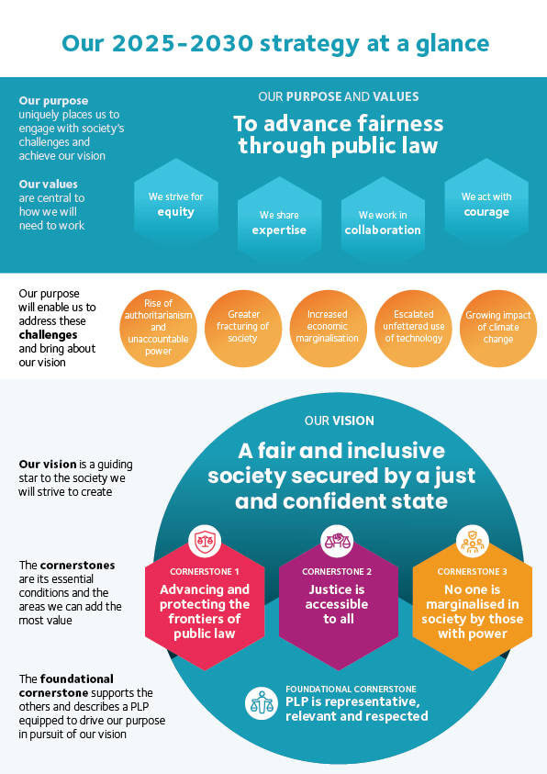

Employment information
Job title: Trainee Solicitor (Justice First Fellow)
Reports to: Lead Lawyer in Wales
Contract term: Fixed 2 year contract
Location: Cardiff, Wales. Homeworking within flexible working policies. New starters are required to work in the office 3 days a week for the first 3 months.
Hours: Full-time (35 hours per week)
Salary: £29,698 (plus cost of living increase)
Pension: 10% per annum after one year. Statutory minimum during first year.
Leave: A full-time member of staff has 25 ordinary annual leave days each year in addition to bank holidays (usually 8).
Probation period: 6 months. Benefits may be offered at a reduced level during the probation period.
Payment method: Payment is made by electronic transfer on or shortly before the 15th of each calendar month covering payment for that same calendar month.
Flexible working:
PLP is a family friendly employer. We are open to flexible working arrangements from day one, including those that will enable the post-holder to accommodate their care responsibilities.
PLP employees may be requested to attend occasional evening meetings. However, PLP recognises that post holders may have other commitments and seeks to be as flexible as possible in this regard. In addition, reasonable notice will be given of such commitments outside normal working hours where possible, and time off in lieu may be taken by arrangement.
This role will require regular trips to our London office (paid for by PLP), especially in the first few months.
These details are provided for information only and do not form part of an employment contract or job offer.
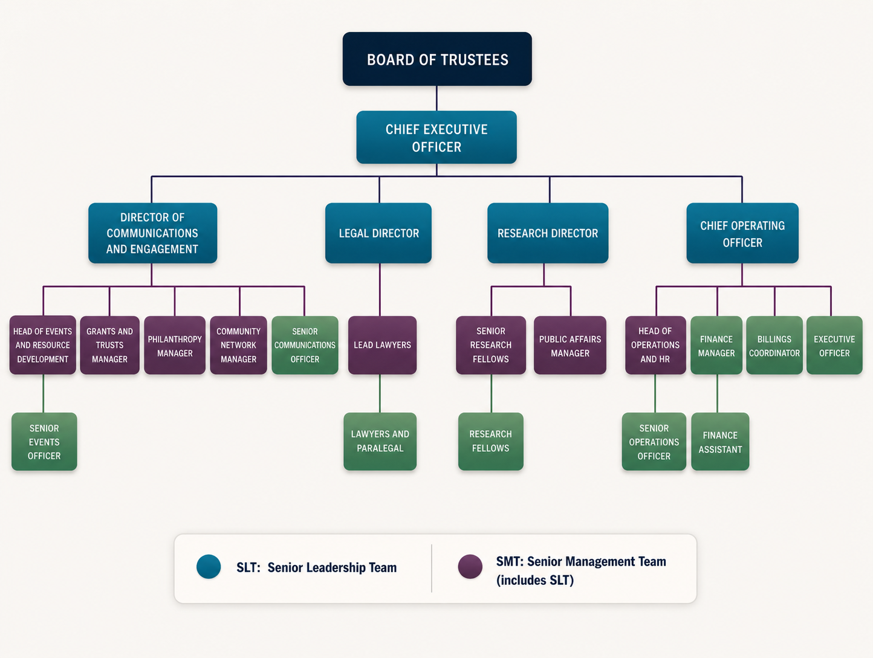
2021/22 V2

Job Purpose
The Trainee Solicitor will be based in PLP’s Casework Team, responsible for providing legal and administrative support to PLP’s Casework Team.
Working collaboratively with PLP colleagues, clients and partners, the Trainee Solicitor will support with the delivery of PLP’s strategy and goals.
The role will be based in Wales and will combine a focus on our public law work in Wales while also providing opportunities for working across all our casework.

Key relationships
Managed by one of our Lead Lawyers, the Trainee Solicitor works closely with other members of the Casework Team as well as collaborating with colleagues across PLP.

Primary Duties and Responsibilities

The following is an illustrative but not an exhaustive list of the primary duties and responsibilities of the role.

Casework and Litigation
Under the supervision of PLP’s Lawyers, provide general support to the work of the Casework Team including:
- Managing new client enquiries and referrals.
- Drafting casework related correspondence and other documents.
- Assist Lawyers with legal research and case preparation.
- Attending client meetings, court hearings and other meetings where appropriate.
- Liaising with clients, counsel, courts and third parties as appropriate.
- Providing general administrative support to the Casework Team including preparing court bundles, booking meetings, opening files, supporting caseworkers with general file and diary management, archiving and billing.
- Assisting with training and induction of new Casework Team members including in relation to the Casework Team’s procedures and systems.
- Meeting financial targets and ensuring that all time recording and legal aid and other billing is undertaken in a timely way.
- Developing own caseload under supervision.
- Managing and prioritising own task list and ensuring deadlines are met.
- Ensuring compliance with regulatory and professional standards.
- Recording competencies and completing training objectives and taking increasing responsibility as competence develops.
- Supporting the Casework Team in developing and maintaining networks, partnerships and referral sources to proactively generate work.
- Developing and running a social justice project under supervision.

Cross-departmental Work
Contributing to the work of, and collaborating with, other internal teams to progress the implementation of PLP’s organisational and casework strategies including but not limited to:
- Supporting our Communications Team in respect of media and communications in relation to our casework.
- Collaborating with the Research and Public Affairs Team including on research or policy outputs, activities and advocacy opportunities as appropriate.
- Contributing to fundraising applications at the request of the Grants Manager.
- Working with our Events Team to assist in developing, maintaining, and delivering training courses, conferences and published materials as required.
- Supporting the Finance and Operations teams including in relation to billing and archiving.
- Working with other internal teams as required from time to time, beyond the areas set out above.

General Duties
- Participating with other staff in the day-to-day operation of PLP’s activities.
- Contributing to PLP’s general development including improvement of systems, processes and ways of working.
- Ensuring work is carried out in accordance with PLP’s policies, procedures, and relevant legal and regulatory requirements.
- Providing support in relation to PLP’s day-to-day operation of activities, including accounting and financial reporting (including to funders).
- Attending meetings and other fora and representing PLP as required.
- Undertaking general administration, correspondence and document preparation efficiently, delegating as appropriate.
- Assisting others with gathering data for monitoring and evaluation, both internal for SLT/Board and external for funders and stakeholders, including the Legal Aid Agency.
- Attending occasional evening meetings. These and other events may also result in the post holder having to be away from home overnight. However, PLP recognises that post holders may have caring and other commitments and seeks to be as flexible as possible in this regard. In addition, reasonable notice will be given of such commitments outside normal working hours where possible, and time off in lieu may be taken by arrangement.
- Undertake other tasks appropriate to the role as required.
Person Specification: Trainee Solicitor
Knowledge, skills and competencies | Essential | Desirable
Holds a degree and has passed SQE 1 | ü
Law degree or Post Graduate Diploma in Law |  | ü
Working towards solicitor qualification | ü
Understanding of, and commitment to, the strategic aims of PLP | ü
Awareness of current social and legal issues in the public law field | ü
Previous paralegal or other legal work experience |  | ü
Understanding of and ability to conduct legal research | ü
Ability to communicate well both orally and in writing, to diverse audiences | ü
Ability to work with clients who may be vulnerable, distressed or dealing with difficult situations | ü
Ability to meet reasonable financial targets | ü
Organised and ability to prioritise effectively | ü
Good attention to detail | ü
Experience of working in a legal aid practice including experience in legal aid applications, CCMS and legal aid billing |  | ü
Ability to plan and run a social justice project with support | ü

Personal qualities, commitment and values | Essential | Desirable
Commitment to PLP’s core values and commitment to understanding and addressing the effects of discrimination in all work, both external and internal, in line with PLP’s Equality, Diversity, and Inclusion (EDI) objectives | ü
Strong communication skills, both internally and externally, and the ability to work flexibly and collegiately within a multi-disciplinary team | ü
Resilience and the ability to learn from setbacks, recognise when support may be needed, and proactively seek guidance and support to perform effectively in the role | ü
Ability to progress work independently | ü
Ability to handle confidential information appropriately | ü
Personal commitment to development and learning | ü
Willingness and ability to travel occasionally and attend evening meetings with time in lieu offered in return |  | ü
Based in Wales or willing to relocate | ü
Right to work in the UK | ü

Application process
PLP is an equal opportunities employer and Disability Confident Employer. We welcome applications from individuals regardless of age, disability, gender, gender identity, marital status, pregnancy/maternity, race, religion and belief, sex or sexual orientation.
Candidates may ask for clarification of elements of the person specification and/or the application process, and may discuss any issues that might impact on how they would be able to undertake the work. PLP will not discuss issues that may give any candidate information that would give them an advantage in their application.
To apply, please go to LEF’s JFF page at: https://lef.org.uk/justice-first-fellowship/how-to-apply
Applications open on 12 October and close on 30 November 2026.
A recruitment panel will be nominated for each vacancy. The recruitment panel will use the completed application form to assess each candidate's ability to meet the essential requirements of the job as set out in the person specification using a scoring system. The highest scoring applicants will be interviewed.
Interviews will be held in Cardiff on Wednesday 27 and Thursday 28 January 2027 (ideally in person).
Further information about the interview process will be provided to successful applicants. Interviews will usually consist of at least one practical test of your abilities relating to the role and a standard interview with a panel of at least two people. Please let us know in advance of your interview if you have a disability and require reasonable adjustments for the interview and/or assessment process to ensure the process is fair and equitable to all applicants.
Interview questions will be decided in advance based on their relevance to the job description and person specification and scored separately by interviewers. A score sheet will be set in advance, interviewers may only use information from the application form, the interview and any other assessment methods to inform their score.
PLP keeps assessment records/notes for all applicants, whether shortlisted or not, for 12 months. They are stored securely and then destroyed securely after the above period.
All short-listed candidates shall be notified of their selection decision and can obtain feedback from the assessment if they request it. All such requests are dealt with by HR who may pass them on to the relevant person if applicable.
Equality statement of intent
As an employer, PLP will treat all employees and job applicants equally and fairly and will not unlawfully discriminate against them. This also applies to volunteers, interns and anyone undertaking work experience with PLP. Our commitment to equal treatment extends to arrangements for recruitment and selection, terms and conditions of employment, access to training opportunities, access to promotion and transfers, grievance and disciplinary procedures, demotions, selection for redundancies, dress code, references, work allocation and any other employment related activities. Specifically, PLP will endeavour to ensure that:
- Whenever practical, we will recruit and maintain a workforce which broadly reflects the diversity of the community in which we operate and serve. We will ensure that the style and content of our job adverts and recruitment materials convey this commitment and always includes the statement that "The Public Law Project is an equal opportunity employer".

- Subject to cost, we will ensure that job opportunities are advertised widely and to diverse audiences. Where appropriate, PLP will take positive action measures to attract applications from all sections of society and especially from those groups which are under-represented in our workforce.

- We treat all job applicants equally and fairly and do not unlawfully discriminate against them. We do this by ensuring that we operate an open and fair recruitment process and making decisions using selection criteria which do not discriminate.

- We will take every possible step to ensure that employees and volunteers are treated fairly, with the aim of creating a culture that respects and values each other’s differences, that is free of discrimination and promotes dignity, equality and diversity, and that encourages individuals to develop and maximise their true potential.

- We recognise our continuing responsibility to develop the potential of all employees, removing any barriers, bias or discrimination that prevents progression or full contribution to the organisation’s performance. We will ensure that selection for promotion, training or other benefit is free from discrimination of any kind and is based on the employee’s experience and abilities and the needs of the job.

- We will make clear to all employees, volunteers and trustees that anyone who works for PLP in any capacity is entitled to be treated with dignity and respect, and that unlawful discrimination, intimidation, harassment and victimisation are disciplinary offences which will not be tolerated by the organisation and may lead to disciplinary action. We will provide clear and accessible procedures allowing allegations of such conduct to be promptly and sensitively investigated.

- We will provide flexibility to employees in relation to work requirements that may significantly impact on their personal needs and responsibilities, and we will seek, as far as possible, to foster a culture that ensures an appropriate work – life balance. We also aim to be aware of days of cultural or religious significance that employees may wish to observe in an appropriate manner.

Privacy notice
When you apply for a job with PLP we will need to collect information about you including your employment history and contact details so that we can assess your suitability for the role and inform you about the progress of your application.
Your records will be kept securely whilst we consider your application. If your application is unsuccessful, we will keep your data until 12 months after the decision was made. If successful, your recruitment information will be kept for 6 years after your last day working with us.
If you opt to provide equal opportunity data to PLP this will be anonymised and retained only as long as is necessary to record the recruitment decision against the anonymised data and no longer than twelve months.
We do not share recruitment information with third parties.

We are committed to securing genuine equality of opportunity in all aspects of our recruitment and employment practices. We will make reasonable adjustments to the recruitment process and the job role to support applicants and employees with disabilities or long-term health conditions.

